Working for a better future. | 125 Lake Ave., PO Box 160,  Hill City, MN 55748  218-697-2301  cityhall@hillcity-mn.com  www.hillcity-mn.com

City of Hill City will be accepting closed bids for the following forfeited vehicle. Bids can be mailed or dropped at City of Hill City, PO Box 160, Hill City, MN 55748. Minimum Starting Bid is $20,000 no bids will be awarded for under the minimum. Bids will be accepted until 4pm on September 15th, Bids will be opened on September 16th.
2014 Dodge Ram 3500 Cummins Dually
238,275 Miles
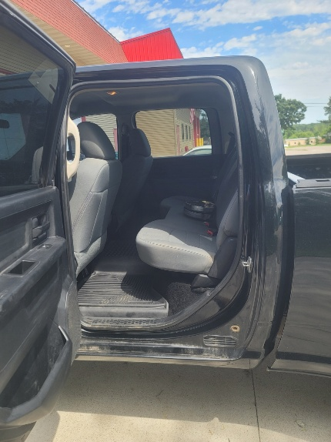
Can be seen at the lot across from Sunnys, test drives will be coordinated by reaching out via email or phone 612-986-9826 or rsaxton@hillcity-mn.com
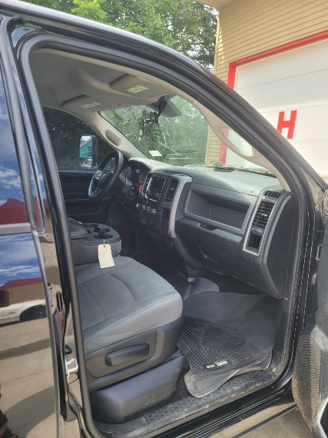
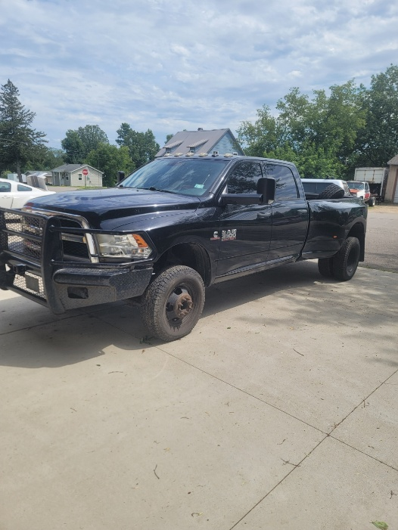
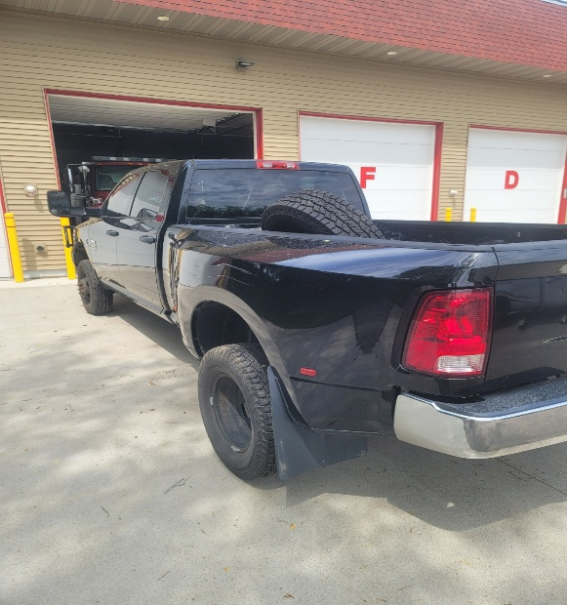
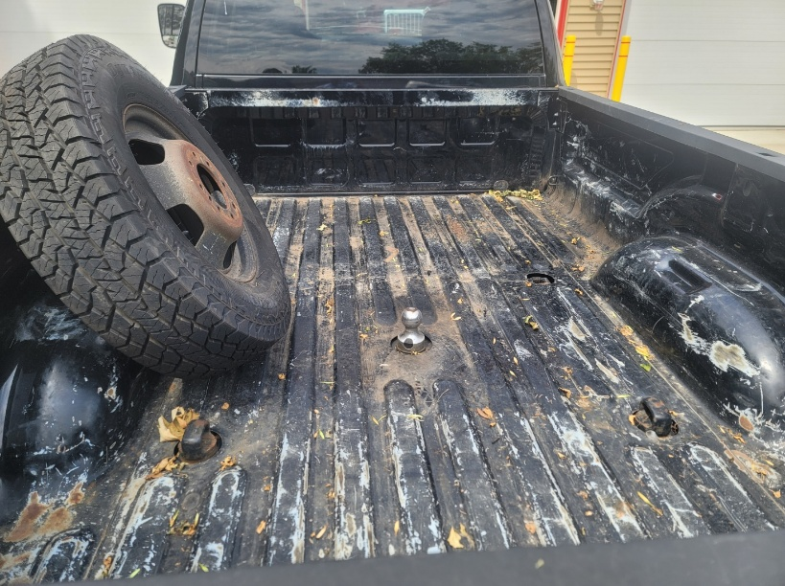
The City of Hill City reserves the right to accept or reject any and all bids

